A Model for Assessing Functional and Systems Architectures in Near-Earth Asteroid Capturing Process

Ryan T. Patton[1]

*Missouri University of Science and Technology, Rolla, MO, 65409*

**This paper presents a model for assessing functional and systems architecture as relevant to capturing near-Earth asteroids (NEAs). The proposed system realized after investigating several concepts for facilitating an asteroid mining mission. Two schools of thought emerge on how best to mine asteroids, in-situ mining and asteroid transportation to Earth. The resources needed to support future space missions or for dwindling Earth resources necessitate the potential development for mining asteroids. By focusing on a system to lock a NEA to an integrated supporting spacecraft, the system retains the ability to mine on-site or to transport back to Earth. The proposed system supports innovative methods to counteract massive, high-velocity impacts and stabilize large-radii sized objects of various compositions. In-situ mining generally works around accommodating other missions. By focusing on capturing the NEAs, the system supports an easily integrable solution to any spacecraft regardless of its intended mission.**

1. **Nomenclature**

ASE = Autonomous Sciencecraft Experiment

CAD = Computer Aided Design

CASPER = Continuous Activity Scheduling Planning Execution and Replanning

ISS = International Space Station

JAXA = Japan Aerospace Exploration Agency

KPP = Key Performance Parameter

LAN = Local Area Network

NASA = National Aeronautics and Space Administration

NEA = Near-Earth Asteroid

REE = Rare Earth Element

SCL = Spacecraft Command Language

SLS = Space Launch System

3D = Three-Dimensional

1. **Introduction**

A developed model for a NEA capturing system can be analyzed throughout this paper. The system’s main functionality is to stabilize a NEA to support its mining. The proposed system exhibits economic and technical qualities paving the way in asteroid mining for future innovation. The means to capture, stabilize, and mine massive asteroids is still in early development and difficult to quantify its potential payoff. Asteroids’ value in commercial manufacturing and as fuel in more feasible space missions drive the technical development of asteroid mining in recent years as a future alternative to limited resources in different environments. Most modern research and development on the topic delves into planetary defense against asteroids using lasers or mining regolith as it would apply to National Aeronautics and Space Administration’s (NASA’s) ambitious goal of exploring Mars and supporting long-term inhabitance of Mars. The paper showcases the proposed system’s attributes to capture NEAs and the means by which it would integrate into various spacecraft’s and space missions alike, showing its architecture and assessment to validate the feasibility of its application.

The presented NEA capturing system includes not only its functionality for capturing the asteroid but the supporting interfaces for coordinating its movements. The scope of the system provides enough breadth to support logistics immediately before and after entering the vicinity of an asteroid to lend credence to its practicality and realism. The critical subcomponents consist of the capturing system’s netting, anchor captors, locking mechanics, autonomy, and supporting interfaces. The system derives its value from these subcomponents’ design as they determine the majority of the system’s testability and growth for future innovation. Decision matrices seen in the figures below each subsection showcase the logic behind each subsystem’s design, hoping to shed light on the demand for further analysis in the field of asteroid mining.

1. **Fundamental System Design**

The main subcomponents of the NEA capturing system include the netting, the metal anchor captors with extending/retracting capabilities, the locking mechanics, the autonomous communications, the hardware/software interfaces, and the spacecraft integration. Figure 1 seen below shows a conceptual functional design to exemplify what the system looks like when fully extended. The net-releasing subsystem communicates with the sensors to automatically release when the asteroid reaches a certain trajectory and distance away, immediately followed by the metal anchor captors to absorb the high-velocity impact. The functionality of each subcomponent contributes to an overall system supporting resource extraction.

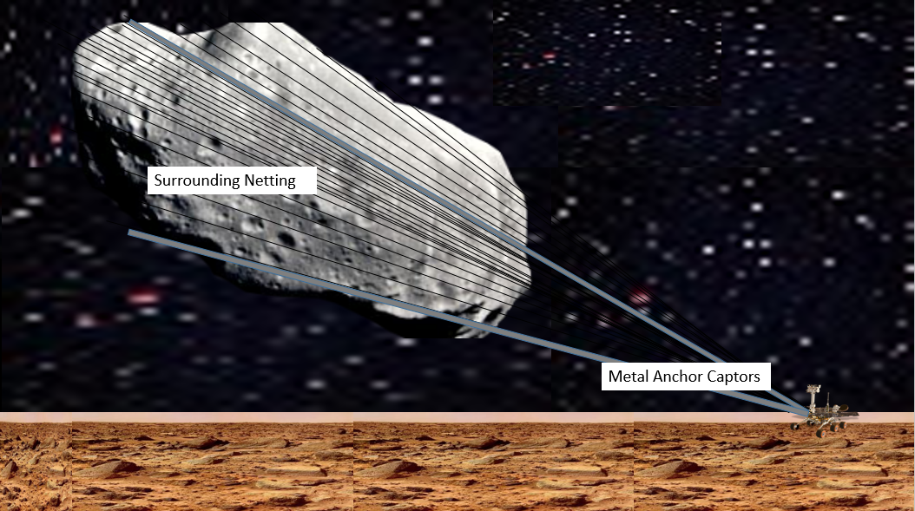

**Figure 1. Concept System Design**

Although mining Rare Earth Elements (REEs) and other resources provided by asteroids may not prove worthwhile at the moment, the economic predictions mostly assume a linear timeline for developing asteroid mining technologies, ignoring the exponential growth occurring all across the commercial space industry. Right now, resources are limited to scientific samples, regolith as radiation shielding and Three-Dimensional (3D) printing, 3D printing metal elements, and water as fuel and life support. Bigger and better telescopes are produced yearly and placed in strategic locations for discovering the full potential of asteroids. The growth of commercial space startups indicates the piqued interest in cashing in on the new space race before commercial cash flows are established. The conceptual freedom and funding in asteroid mining while best practices need further research and development supports the creation of the following system and encourages further study in the mechanics of the system’s interactions in the space environment.

The purpose of the netting and anchor subsystems working together was to approach one of the major problems facing asteroid mining, the most efficient way to transport an asteroid. After deciding on a solution for capturing the asteroid, the studies on how the locking mechanisms would work after capturing the asteroid followed suit. In conjunction with all three critical subsystems, the means to support capturing and locking the asteroid garnered significant attention. A system intended for the future needed to reflect its future endeavors so the system was decided to be completely autonomous to eliminate operator error and resources needed in space for humans. The intent of the system is to delegate the human role(s) needed for asteroid mining to interface operations from Earth or established bases in space to mitigate financial risk. To reduce the complexity of the system and increase its appeal to corporations across the commercial space industry, the system’s design supports integration onto various spacecrafts with a universal design. A brief conceptual mission overview describes a typical mission the system is intended for to reduce ambiguity. Lastly, the performance specifications and overview of system limitations/benefits validate the system’s design. Stepping into each crucial design decision shows the criteria used for effective evaluation and the why’s for credibility assurance.

1. **Netting Trade Study**

The netting needed for an asteroid mission needs to be extremely durable, stretchable, and flexible. The netting encapsulates the asteroid until the reinforced metal anchors can slow down the asteroid to a manageable speed. Tears in the netting are unacceptable for a consistently reliable system. The main deciding factor for picking the netting material is its durability because an asteroid traveling at high speeds could easily tear the netting’s fabric and escape the capturing system. Although cost was considered, the cost to produce a large surface area of netting upped the costs of the system more than the specific material options. Achieving reusable netting more than makes up for the associate costs.

Efforts are already under way to capture large objects in space with reusable netting. One such initiative is cleaning up space debris traveling at speeds up to 17,000 miles per hour by releasing a large surrounding net from a satellite. The RemoveDebris netting successfully slowed down objects in space enough so they would fall to Earth and is currently experimenting with a thin drag sail to actually drag the objects to a desired location. By taking advantage of electromagnetic forces near Earth, and in the future throughout deeper reaches of space, the objects slow considerably to propel them in the desired direction.

The netting used in the proposed system would utilize a very similar construction used by Japan Aerospace Exploration Agency (JAXA). JAXA’s desire to clean up space junk is one of the first of its kind so in the future, more desirable polymers/alloys may reveal to be more beneficial but utilizing an aluminum and steel wire mesh blend guarantees state of the art technology for commercial success. The time needed to construct just a 700-metre-long netting took JAXA many years to perfect but with facilities established, they plan to manufacture a 10-kilometre-long version to capture satellites in less than five years.

JAXA’s netting still needs further testing to see how durable it is to tears from small debris objects or micrometeoroids. Assuming further refinement of its nettings, similar netting principles would be applied to the proposed system to mimic the effects on a larger scale. Kevlar, Kevlar blends, various Aluminum alloys, various Steel alloys, various Titanium alloys, and various other polymers were considered. The manufacturability and proprietary Steel/Aluminum blend used by JAXA would appeal the most to current investors.

1. **Anchor(s) Trade Study**

The anchor catching mechanisms supporting the netting to provide the main resistance against a high-velocity asteroid impact. The configuration of the anchors should be such to optimize the space for impact against the asteroid. The anchors need to be light weight for balancing the weight of the system as a whole and the adjoining spacecraft. Combining the two main characteristics of the anchor, the metal anchor captors main design consideration was its durability compared to its own weight. Titanium and aluminum alloys, common on most space venture crafts, were mainly considered with favoritism towards the more expensive, durable options.

Returning to the netting potential, the RemoveDebris project also aims to make use of harpoons along with netting to capture outer space objects. The netting and harpoons, tested separately, could potentially combine such as in the proposed system to avoid a single point of failure.

1. **Locking Mechanics Trade Study**

The locking mechanics after retracting the surrounded asteroid back towards the system take advantage of the relative weightlessness of space and the cradle provided by the anchors. By ensuring the connectivity of the anchors, the asteroid will be almost completely trapped in space regardless of if a locking system is in place. The locking mechanics are only needed for entering Earth’s atmosphere. Upon entering Earth’s atmosphere, the asteroids proximity to the system’s main body shall be no greater than 1 meter. Suction adhesion will be used to achieve this.

1. **Autonomy Trade Study**

For a system to function autonomously in space without the possibility of at least some human assistance for maintenance, adjustments, repairs, etc… the design of the system must take into account many “what if” scenarios. By incorporating live video feedback from any relevant angle and configuring proper satellite signals, the status of the system can be monitored well.

The most relevant example to conduct the proposed system’s autonomy would be NASAs Autonomous Sciencecraft Experiment (ASE). The proposed system aims to select economically beneficial NEAs after computational analysis. The ASE analyzes image data to detect trigger conditions such as science events, interesting features, changes relative to previous observations, and cloud detection for onboard image editing. Given the current studies of the ASE, an asteroid would directly fall into the scope of its studies of the ASE and its developed software in Spacecraft Command Language (SCL) and Continuous Activity Scheduling Planning Execution and Replanning (CASPER). With 15 years of relevant data collecting and tweaking of its autonomous decision-making, utilizing technologies in the ASE would be the easiest path for autonomous evaluation of NEAs and downlinking only the highest valued data for human observation and decision making. Utilizing further developed ASE technologies allows for the necessary amount of human interactions in a NEA capturing mission to reduce human observation time to practically zero. With the implementation of robotics for interfacing, the human observing from Earth or an established base in space, would essentially only need to perform the critical functions such as releasing the net and anchors and retracting the captured asteroid to lock into position.

1. **System Interfaces**

The interface of the proposed system requires close to real-time processing during critical aspects of the mission. With personal Web access now in space thanks to Crew Support Local Area Network (LAN) on the International Space Station (ISS), remoting into computers driving the decision making process aboard the proposed system is currently within the picture. With all of the common aspects of Web access now available such as e-mail, Internet Protocol telephone, and videoconferencing capabilities, remoting into the system near Earth’s bandwidth would be a simple task. Modifications would need to be made to support LAN service on a deep space mission but the technologies currently exist if needed.

The possibility of capturing deep space asteroids means the system shall be hardwired in a way conducive to no single point of failure. The security of the system would be vital and would hopefully work in collaboration with technologies aboard the ISS and NASA in particular to avoid to create joint security ownership. The software, especially with remote capabilities, would need the latest security measures built into its system and the ability to be regularly updated. Although the implementation of security measures outside of how they apply to the system is out of the scope of the proposed system, the system must be designed with security measures in mind which flows down to the hardware and specifications.

1. **System Integration**

Applying systems integration to the proposed model means the system should be able to attach to current space crafts with a vacuum seal, most notably the Atlas V rocket and the Mars Rover. The two spacecrafts mentioned are the favorites for any new space missions at the moment. The system needs to compartmentally fit aboard the Atlas V rocket with weight constraints to adjust for the enormous cost for adding even miniscule amounts of weight. The system will need collapsible capabilities to reduce its size for the precious space in the Atlas V and the Mars Rover. The system shall balance its weight accordingly and further analysis needs to study how the attachment of an NEA onto either the Mars Rover or Atlas V rocket affects its center of gravity in space and within Earth’s atmosphere to avoid dangerous acceleration and trajectories. Furthermore, the system needs to integrate into its appropriate craft in such a way that its netting and anchors can extend outwards to capture a NEA without reducing the spacecrafts capabilities and retaining a vacuum seal. Ideally, the system’s attachment with a vacuum seal could easily adjust to accommodate future spacecrafts as well such as cube satellites, various other rovers, the ISS, etc… The proposed system aims to reduce the complexity of its design by providing a universal seal capable of configuring to the exterior of a system.

1. **System Mission Planning**

Along with system integration, the system’s design incorporates features to accommodate the space environment in general and the conditions it may find itself in on an actual mission. The system will contain 10-15 layers of collapsible radiation shielding of various materials such as Mylar, Aluminum foil, polyeurethane, etc… The outermost layers and the core structure must protect against space dust, solar events, and extreme weather observed near some bodies’ atmospheres. Extra material to repair the shielding are considered for adding weight to the system. The system heavily relies on the ability in the near future to send out autonomous bodies to address repairs needed for unforeseen disasters.

1. **System Performance and Overview**

Inputs of the system consist of developed software, hardware to support the software and its autonomous features, high-impact resistant structure and shielding for rough space environments, solar power to feed the system its necessary power, LAN connections for systems interfacing from remote locations, communications, properly distributed weight to support its integration into a more navigable craft, extension/retraction capabilities for both its netting and gripping anchors, and a highly tensionable locking system. The contributed inputs support the capture and transportation of a NEA. The purpose of capturing and transporting the NEA is for mining the asteroid of its vital resources as needed, either for commercial uses on Earth or for utilizing limited resources for other space missions.

The previously mentioned trade studies validate the proposed system to show its fundamental logic based on successful applications. Similar research and engineered designs show the potential for successful transportation of asteroids. The best method of transporting asteroids, however, still needs further research. The proposed system’s main advancement lies in its design which infuses both harpoon-type anchors and netting. Both technologies show potential for success individually and so by combining them into one system, a fair amount of inherent risk to both system damage and mission failure is mitigated. Other methods explored include blasting a NEA with nuclear weapons to partition the NEA for easier handling during transportation, ion beams for redirection, laser sublimation, mass ejectors, gravity field perturbations, and thrust pushes known as tugboating. Nuclear blasting does make mining an asteroid more manageable but could also partition the NEA in ways as to eliminate crucial resources from being mined. Nuclear blasting also poses a high risk to any spacecraft within the area as pieces of the asteroid will scatter at high velocities. Ion beams require an enormous amount of propellant to correlate to twice the size of the asteroid diameter to move the NEA, leading to extremely high costs for working with this method. Laser sublimation attempts to sublimate the surface of an asteroid and generate a thrust onto the asteroid. Further development for this study could help validate its potential for future achievement but for now, the technologies don’t exist to sublimate large bodies of NEA enough to generate sufficient thrust. Mass ejectors drill into the surface of an asteroid to extract material and generate the thrust. Not only are vital resources at risk of being accidentally drilled into, but the depths needed to generate thrust requires massive drills that fit better into in-situ mining which could take years to achieve in a systems context. Gravity field perturbations manipulate gravity fields to very slowly direct the asteroid. The cheap cost and scalability to large asteroids are the main appeal of this method but unless strides are made with this method, it would take decades to direct the asteroid back to Earth. Tugboating would be utilized in the proposed method as part of its transportation but tugboating by itself involves setting up various thrusters around the NEA to support its movement. The proposed method improves on the idea by keeping it to one central location and with the asteroid already locked into place, the changes of the asteroid spiraling out of control significantly decrease. Overall, the system proposed provides a more direct method to retrain control while transporting the asteroid as a whole and easily scales to large or small asteroids.

The object-process methodology diagram shown in Figure 2 breaks down a high-level hypothetical on how the system would actually capture a NEA asteroid. Upon arriving near an asteroid’s vicinity determined by computational analysis within the system’s boundary, the same computational engines would classify the asteroid based on an expanding list of machine learning asteroid classification indexes. Not only would the system classify the asteroid but the system would also determine the cost-benefit analysis of capturing the asteroid to prepare for mining. Human interaction is needed during this stage to assist in a final decision due to the current inadequacies in machine learning to account for subjective and critical thinking variables. If the asteroid is deemed worth capturing, more analysis would help determine the amount of catching mechanisms needed to develop the optimal configuration for surround the asteroid and pulling it in for locking.

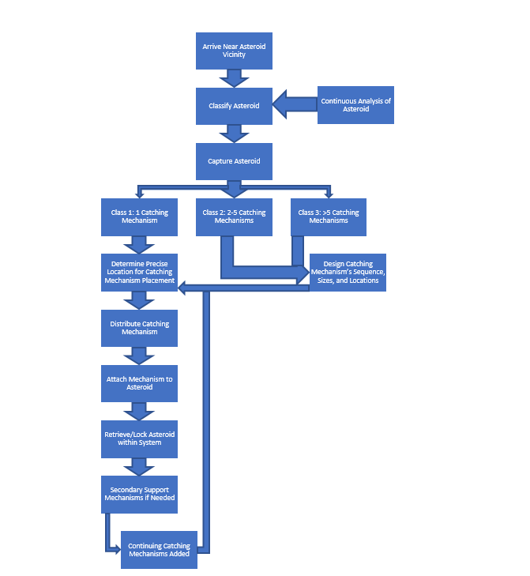

**Figure 2. Systems Object-Process Methodology**

The immediate appeal of in-situ asteroid mining foreshadows its most basic problem, its lack of versatility. By focusing on only an asteroid’s transportation, more time could be allotted to focus on the depth of technological research needed for a versatile asteroid capturing system. In-situ mining creates an extremely fuzzy system where a successful mission depends on an estimated 50-150 variables. An assessment model for in-situ mining would contain so many assumptions and simplifications that the integrity of the model would surely be compromised. The trade studies for each subcomponent show the thought behind each design decision so as to reduce the inherent fuzziness in the system and trace the possible effects of system modifications.

The level-2, modified level-2, and level-3 architectures shown in Figures 4, 5, and 6 respectively provide a demonstrable walkthrough of the components within the system and how it will operate. Each level feeds into the next level of the architecture to retain consistency throughout the design process and validate the design at the next level while exposing any obvious flaws. By jumping from the level-2 to the level-3 architecture, any missing subsystems and/or relationships reveal themselves. The architect must critically think about the critical aspects of the system and envision how the system will work as a whole and how the individual subsystems will work independently. The whole point of a system is to add value to a whole that the individual subsystems cannot achieve as well. The architect drives the process for fine-tuning how the system comes together to generate its new or improved utilities.

After generating an architecture, the architecture needs to be assessed by a created model to prove its effectiveness relative to similar ideas and systems. Before advancing to manufacturing, how will the architect know if the system created is valuable or practical? By combining trade studies with assessment methods, the architect gets a relative idea if the system is worth advancing to further design and manufacturing. During assessment, it may be determined the system is physically not capable of its intended function at which point the idea should be revised or scrapped altogether. An assessment model adds another level of validation to the process to ensure the created system in theory can add value to its objectives. In the proposed system, the assessment model defines the most valuable ‘ilities of the system and finds ways to quantify them and their relative error. By doing this for not only the proposed system but for similar system ideas, the model is validated for future realization.

1. **Proposed Model for Architecture Assessment**

The critical variables needing consideration to build a model for the system are system mass, system volume, system, technology readiness level (TRL), change in velocity, mission risk, system cost, average required power, performance robustness, asteroid alteration, and long-term value defined by the ‘ilities extensibility and reusability. NASA developed a single Cost-Estimating relationship QuickCost model applied to the proposed system’s cost. Based on NASAs risk parameter definitions, the model generated approximately a 3.8/5.0 mission risk meaning there’s a moderate to significant risk of losing mission objectives based on the tailored matrix. Monte Carlo analysis helped define the system’s performance robustness and asteroid alteration based on inputted formulas. The results showed the proposed system easily fit within a 95% confidence interval. The qualitative ‘ilities of extensibility and reusability were utilized to determine the system’s long-term value, giving a score around 4.0. A 4.0 score indicates the model veers towards major extensibility of redirecting an asteroid and a secondary mission would be achievable with minor modifications. All the other variables were explicitly defined by mathematically relevant formulas.

Table 1 seen below defines the 4 critical mission risks later used in aggregation. The Consequence and likelihood values were assigned their respective values based on similar system study evaluations. The consequence for unsuccessful attachment to the asteroid surface gave such a high consequence rating of 5 because the method needs attachment for the physical transportation of the asteroid. Based on the confidence in the ability to attach, the likelihood was given a mere 3. Netting and anchor studies are plentiful and the technology is well-developed to give a 3 rating for potential tears and a mere 1 rating for the likelihood. Again, the asteroid cannot be transported if it will not lock into place and its trajectoral control is lost. The likelihood of this occurring isn’t very high considering the confidence in the suction adhesion method used. The consequence of being unable to achieve sufficient thrust is given a 5 consequence rating because the system cannot physically move without sufficient thrust to bring the asteroid to its mining location. The 3 likelihood rating stems from the ability to use the asteroid’s large mass to generate momentum for thrust if needed. The error is standard when compared to similar systems.

**Table 1. Mission Risk**

|  |  |  |  |
| --- | --- | --- | --- |
| Mission Risks |  | Consequence | Likelihood |
| 1 | Attachment to asteroid surface is unsuccessful. | 5 | 3 |
| 2 | Netting or anchors tear. | 3 | 1 |
| 3 | System unable to lock asteroid. | 4 | 3 |
| 4 | Incapable of achieving sufficient thrust for movement with asteroid attached. | 5 | 3 |
|  | E(%) | 28.75 |  |



**Figure 3. Risk Matrix**

Table 2 below shows the relevant variable values plugged into the relevant formulas for assessment input. The standard error is relatively low compared to other systems by a power of 10.

**Table 2. Delta-V and Performance Robustness Parameters for Input**

|  |  |  |  |  |
| --- | --- | --- | --- | --- |
|  | Change in Velocity and Performance Robustness Parameters | | | |
|  | Average Velocity Change [km/s] | Phi [unitless] | Standard Error | Cy |
| Proposed System | 0.02398 | 0.04152 | 8.32E-04 | 1.62 |

Table 3 below shows the relevant variable values plugged into the relevant background formulas for assessment input. The standard error is a midway point compared to similar systems’ assessment models.

**Table 3. Asteroid Alteration Parameters for Input**

|  |  |  |  |
| --- | --- | --- | --- |
|  | Change in Velocity and Performance Robustness Parameters | | |
|  | Mr [%] | Phi [unitless] | Standard Error |
| Proposed System | 0.00% | 0.07243 | 3.70E-04 |

Since Long-Term Value criteria relied on qualitative evaluation, the ratings given for extensibility and reusability are seen below in Table 4. Both ‘ilities were rated out of 5.0 and given current research in the area, received fairly high evaluations.

**Table 4. Long-Term Value Table**

|  |  |
| --- | --- |
| Long-Term Value | Proposed System |
| System Extensability | 4 |
| Reusability | 4 |
| **Average** | **4** |

For successful aggregation, the criteria had to be weighted relative to each other to put them in relative quantitative terms to each other. The overall focus in forming the ratings was a balancing act between performance, cost, and future potential for technological innovation. Refer to Table 5 below to see ratings.

**Table 5. Weighed Criteria for Aggregation**

|  |  |  |
| --- | --- | --- |
| Criteria | Relative Importance Rating | **Total** |
| System Mass | 3 | **32** |
| System Volume | 4 |  |
| TRL | 5 |  |
| Delta-V | 4 |  |
| Mission Risk | 4 |  |
| System Cost | 3 |  |
| Power | 2 |  |
| Robustness | 1 |  |
| Asteroid Alteration | 3 |  |
| Long-Term Value | 3 |  |

The Probabalistic Rule Aggregation method was used in SimuLink to generate the aggregation results seen in Table 6. By using the ratings out of 5 seen above, pairings are established and regenerated through multiple trials to determine the relative success of each architecture. Different valuations were used for each architecture based on the completedness of the architecture. Multiple criteria can be compared to rank various options throughout the architectures. The parameters used in evaluation were altered to generate different values and a different final aggregation result. All of the changes generated for the parameters generated the same amount of change for each architecture, showing the actual parameters were not near as important when comparing only one system’s different architectures as they may be when comparing multiple system’s architectures.

1. **Solution of the Proposed Model**

The following System Architectures for Level-2, Level-2 Modified, and Level-3 complement each other to craft a well-rounded, complete system. With the interested parties in mind as seen in Figure 3, the architectures through the levels reflect on their system-rounded objectives. The prospector, leading the asteroid mining expedition, needs the investor to fund the expedition and to provide financial support to build the actual contraption. The investor likewise needs a manufacturer for an exchange of money for promised resources. Systems reasoning sets up constraints placed on the architectures through the levels. The systems reasoning diagram sets budgetary and time constraints on a project, ultimately determining the complexity of the design.

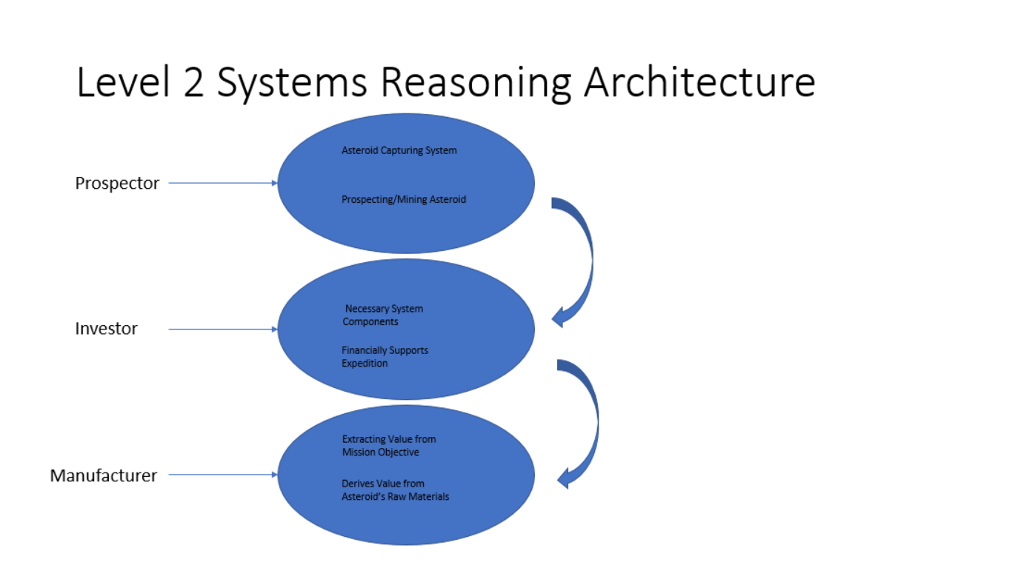

**Figure 4. Level-2 Systems Reasoning**

The level-2 architecture provides a jumping-off point for system considerations. Moving to a modified level-2 systems architecture forces the architect to examine the relationships between the functions and operands to determine the appropriate walk-through. When reading the modified level-2 system architecture in Figure 5, the relationships between the operands and functions provide a mental walkthrough on how the system will work as a whole. The level-3 architecture expands on the level-2 architecture and its relationships throughout to achieve a clearer picture of how the system will be realized. The level-3 architecture does not leave much room open for interpretation. The level-3 architecture shown in Figure 6, reduces the system to such a level to make a level-4 architecture obsolete. Note in the level-3 architecture how functions at the level-2 architecture now are outside of the system boundary. This change stems from modifications to what performance is expected out of the system at level-3. The final results before discussing each individual architecture can be seen below in Table 6.

**Table 6. Aggregation Results**

|  |  |
| --- | --- |
| Aggregation Results | |
| Level-2 | 71.80% |
| Modified Level-2 | 75.30% |
| Level-3 | 77.20% |

1. **Assessing Level-2 System Architecture**

The basic level-2 system architecture can be seen below in Figure 4. Note the secondary functions to the right extend to the system boundary showing explicitly what is part of the system and what falls out of the scope of the system. The level-1 functions consist of the following: arriving, capturing, locking, retrieving, labor-saving, supporting, returning, mining, and profiting. The level-2 functions consist of the following within the system’s boundary: software supporting, scheduling, environment supporting, planning, training, life systems supporting, and mission supporting. Outside of the system’s boundary, the level-2 functions follow: communicating, traveling, landing, navigating, and flight controlling. The level-1 operands are simply the prospector and the spacecraft. The level-2 operands are the object-test system, Space Launch System (SLS), release system, catching system, autonomous movement system, autonomous tension system, asteroid computational analysis system, and the cost-benefit analysis system. The relationships observed in Figure 4 summarize a high-level plan for the approach taken for a prospector capturing an asteroid.

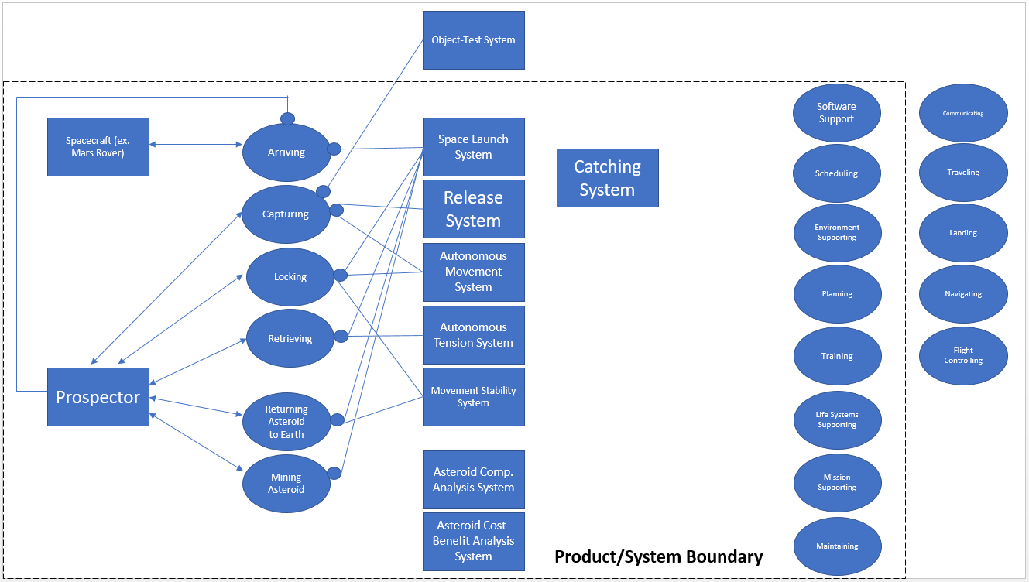

**Figure 5. Level-2 Systems Architecture**

The level-2 architectural framework reflects a high-level functional model for what to expect from the system. For example, the design of the system is not expected to achieve independent propellant or navigation methods, only to cater to other systems’ use of such methods. The functions draw on a generalized concept of what actions define the system. When applying the operands to their functional relationship, the operands describe the crucial subsystems of the system gathering the most attention. The operands listed out all trace their roots back into how they fit into the NEA capturing system as a whole. As attention is turned to the modified level-2 system architecture, the relationships change to reflect the narrower breakdowns of the system at Level-3.

The 71.8% final aggregation score assigned to the level-2 architecture was expected. The level-2 architecture contained the least amount of detail, leading to more fuzzy interpretation when inputted into the aggregation. The normalized values contained a wide bracket of possible inputs in SimuLink. The level-2 architecture could be improved by adding more operands and functions and exploring more valuable relationships between each. More mathematical formulas used to represent the architectures could be generated to improve the accuracy at level-2 as well as at modified level-2 and level-3.

1. **Assessing Modified Level-2 System Architecture**

Analysis of the modified level-2 system architecture stems from revisions due to the generation of a level-3 architecture. The significant differences between the modified level-2 architecture and the level-2 architecture are the addition of three functions, labor-saving, supporting, and profiting, a catching mechanism level-1 operand, and new connecting arrows establishing new relationships. The addition of a level-1 catching mechanism operand supports the most critical aspect of the system, interweaving numerous level-1 functional relationships. The criticality of the catching mechanisms lies in its benign value to physically capture the asteroid, the defining attribute of the system. Without the mechanisms to catch the asteroid, there can be no system. The labor-saving function adds an important feature to the system via the system’s autonomy. The addition of the supporting function brings an added dimension tracing back to how a number of operands at level-2 act as support features. The profiting function added to a modified level-2 generates from systems reasoning. Ultimately, the system needs to add value and a reflection of the value the system and its attributes contribute shows through the profit the system can generate. The new connecting arrows can be examined to trace their relationships which ultimately comes from refining how the system interactions will function.

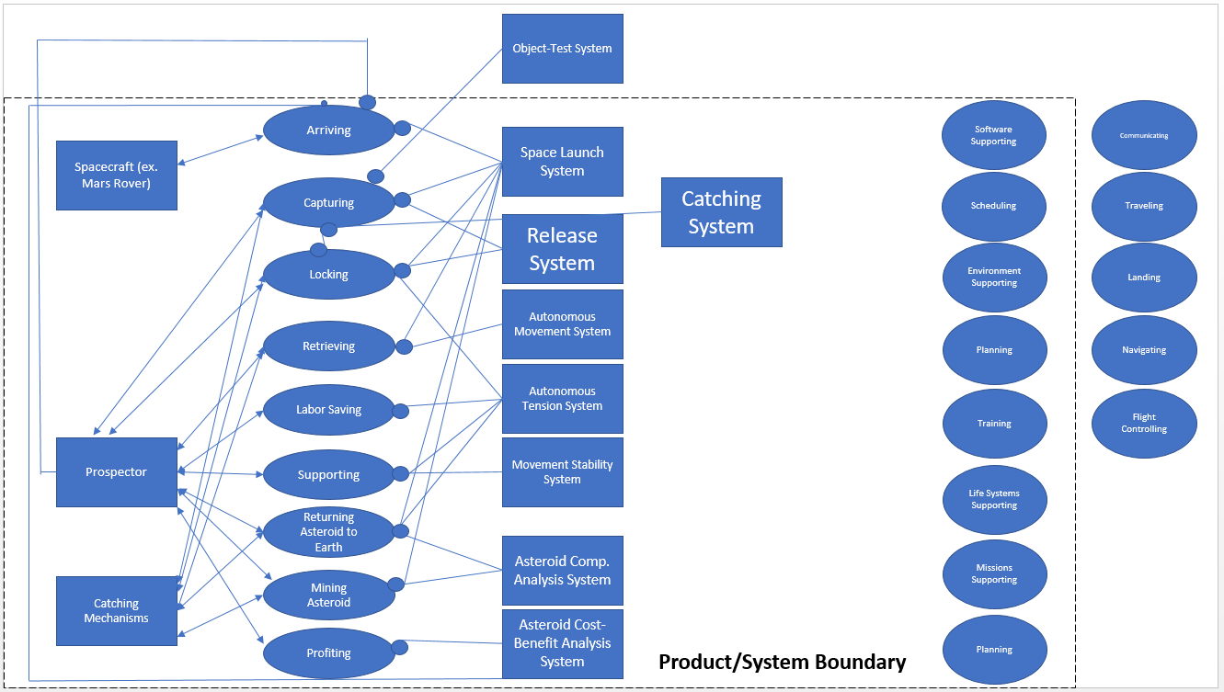

**Figure 6. Level-2 Modified Systems Architecture**

The inter-connectedness to the Level-3 Architecture shows the thought for planning the intricate details of the system. The numerous connecting relationships aim to avoid ambiguities and shed light on all of the supporting features of the system. Now, a computer aided design (CAD) model and prototype could easily be generated for testing and evaluation.

The modified level-2 architecture generated assumed results. The 75.3% result represents an improvement compared to other studies’ architecture evaluations which hovered around 65%-73% at its highest. The improvement comes from the revisions to the level-2 architecture. The system gained significant refinement at level-2 allowing for more detailed input into the aggregation equation. Still, the aggregation result was lower than the level-3 architecture’s results because at level-2 the system will just not contain as much detail as level-3 and the correlations capable of being inputted aren’t as defined.

1. **Assessing Level-3 System Architecture**

The level-3 system architecture provides sufficient details of the inner-workings of the system to corroborate its eventual realization. The thought given to the 3rd-level of the architecture puts the system into more of a mission planning and concept of operations frame of mind. The functions added at level-3 consist of connecting, interfacing, configuring, estimating, timing, applying, measuring, testing distributing, consulting, autonomizing, and restructuring. The operands added at level-3 consist of operating system, sensors, interface, cube satellites, propulsion system, robotics, wiring, down/up link, communications, visuals, avionix, controls, navigation, locking support, and structural support. Figure 6 shows the various relationships formed between the operands at level-2 and the functions at level-3 and the functions at level-3 with the operands at level-3. The newly developed functions at level-3 formed as a direct reflection of the level-2 operands to flow into how the level-3 operands would operate. The level-3 operands provide new, more detailed subcomponents of the system to create a more detailed picture of how the system functions.

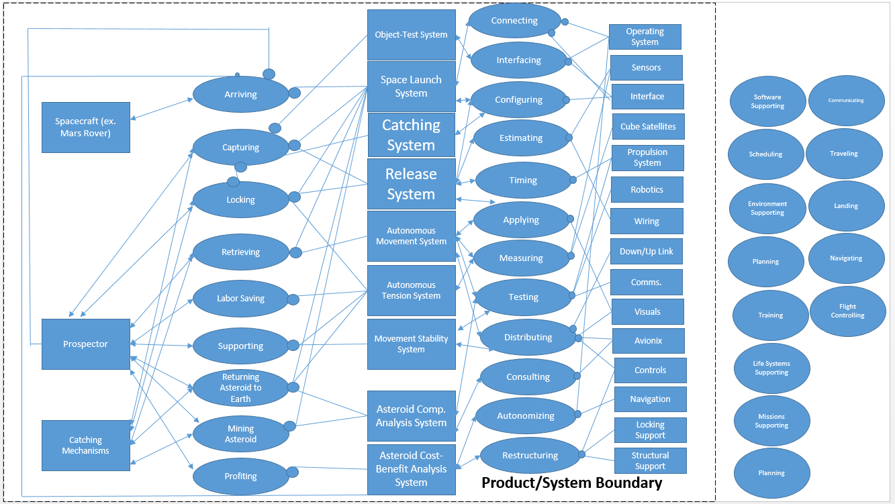

**Figure 7. Level-3 Systems Architecture**

The level-3 architecture represents the final level of sufficient detail to design the system. Enough thought has been given to the necessary components needed in the system.

The 77.2% mark shows very impressive margins of success relative to the mission. Expectedly, the level-3 architecture generated the highest aggregation percentage result. At level-3 the inputs increase at a level past exponentially. By the aggregation results increasing from level-2, to level-2 modified, to level-3, the system is validated without fault. A level-3 architecture generating a lower percentage than the level-2 or modified level-2 architecture would show the additional inputs at level-3 do not validate the system and either the inputs need revision or the system as a whole is poorly designed.

1. **Discussion of Results**

The thought needed to conduct level-2, modified level-2, and level-3 architectures showcases the intrinsic detail present in the system. The research given in the trade studies hammers out the specific system details to form a realistic portrayal of the technologies to utilize in a future prototype. The previous studies presented can now be analyzed to determine how successful they will be using the ‘ilities of the system as fuzzy grading criteria.

The assessment criteria for an applicable model may include design considerations such as extendable, sizable, flexible, durable, operable, etc… A Kiviat Chart illustrating what a fuzzy evaluation based on design considerations may be seen in Figure XX. Early on in the design process, the system may be generally assessed by further defining fuzzy criteria. For example, an “unacceptable” system may read “Architecture is unacceptable if all the key performance parameters (KPPs) are more than 50% away from their minimum numerical values assigned to their respective categories”.

**Figure 8. Kiviat Chart Fuzzy Evaluation**

With each system comes a certain degree of uncertainty afforded by human error in judgment. The assessment model seen in Figure 8 quantifies the uncertainty based on usability as related to the particular NEA capturing system. Information both static and dynamic may change throughout the system and its related processes. The assessment model captures each evaluation criteria’s desired attributes for structure and functionality. By grouping certain principles and introducing preferred relations into the system design process, a perceptual mathematical model can be developed.

The studies of asteroid mining assessment models shows obvious inconclusive results. One study, claimed to derive value from strictly the water in asteroids and placed the system in a mission setting claiming the only value in asteroids is from water as a source of fuel. The bold claim is well-researched but poorly executed, forgetting to account for various developing technologies to transform the whole space landscape.

As mentioned earlier, most studies contained aggregation results with systems achieving 60-75% showing the results achieved were positive and expected. Additional research altering the evaluation weights may significantly alter the results which were not tested in the scope of this study.

1. **Conclusion and Future Work**

In the coming years, developments for long-distance space missions will continue to grow exponentially. By forming early conceptual designs to facilitate mining asteroids, a concept of operations will already be in place waiting on only the development of adjacent technologies.

With the validation of the assessment model, the model would be worth pursuing forward to manufacturing and further design studies. Additional assessment methods should in theory show the model should work but with the numerous aggregation methods available, plentiful further analysis could be generated. Different weights could be given to the evaluation criteria for further study. Using more formulas to help define the evaluation criteria instead of fuzzy ‘ilities would lend more confidence to the results of the assessment. Although significant room for improvement in the assessment model exists, enough of the criteria were sufficiently defined to feel confident in the level-2, modified level-2, and level-3 general trendlines.

The proposed system utilizes ventures across different areas of space technology to design a state-of-the-art concept. The rationale behind each design decision contains roots in current practices either in testing or deployment. The potential net worth of mining even one asteroid, much less finding a consistent process to mine asteroids, could yield a huge payout in billions or even trillions of dollars. By proposing a cost-effective concept with engineered foundations, aspects of its design can be picked and pulled for relevant applications in other space projects.

**References**

*Electronic Publications*

[1] “A systematic assessment of asteroid redirection methods…” Available:

<https://www.researchgate.net/publications/282307741_A_systematic_assessment_of_asteroid_redirection_methods_for_resource_exploitation>.

[2] “ase,” *NASA* Available: <https://ase.jpl.nasa.gov/>.

[3] *Asteroid Mining* Available:

<http://large.stanford.edu/courses/2014/ph240/credend1/>.

[4] Choi, C. Q., “Asteroids: Fun Facts and Information About Asteroids,” *Space.com* Available:

https://www.space.com/51-asteroids-formation-discovery-and-explorations.html.

[5] Dunbar, B., “NASA Extends the World Wide Web Out Into Space,” *NASA* Available:

<https://www.nasa.gov/home/hqnews/2010/jan/HQ_M10-012_ISS_Web.html>.

[6] Grush, L., “Satellite uses giant net to practice capturing space junk,” *The Verge* Available:

<https://www.theverge.com/2018/9/19/17878218/space-junk-remove-debris-net-harpoon-collisions>.

[7] Maxey, K., “Asteroid Mining – Who Wants to be a trillionaire?,” *Engineering.com* Available:

<https://www.engineering.com/DesignerEdge/DesignerEdgeArticles/ArticleID/15308/Asteroid-Mining-Who-Wants-to-be-a-Trillionaire.aspx>.

[8] “Overview,” *NASA* Available:

https://solarsystem.nasa.gov/asteroids-comets-and-meteors/asteroids-overview/.

[9] Ruthkin, A. H., “Japan’s huge magnetic net will trawl for space junk,” *New Scientist* Available:

<https://www.newscientist.com/article/mg22129534-800-japans-huge-magnetic-net-will-trawl-for-space-junk/>.

1. Graduate Student, Department of Engineering Management and Systems Engineering, INCOSE associate member